**SECTION A-46 MARKS**

**Attempt** all **questions in this section.**

1. Sodium-24 which is used as an electrolytic tracer decays by emission of a beta particles and two gamma rays with half-life of 15 hours. Write the nuclear reaction for the decay of sodium-24. (01 mark)

……………………………………………………………………………………………………………………………………………………………………………………………………………………………………………..

1. 2.4g of sodium-24 were allowed to disintegrate for 72 hours. Calculate the mass of the radioactive isotope that decayed. (04 marks)

…………………………………………………………………………………………………………………………………………………………………………………………………………………………………………………………………………………………………………………………………………………………………………………………………………………………………………………………………………………………………………………………………………………………………………………………………………………………………………………………………………………………………………………………………………………………………………………………………………………………………………………..

1. State any two other uses of radioactive isotopes. (01 mark)

…………………………………………………………………………………………………………………………………………………………………………………………………………………………………………….

1. The atomic number of chromium is 24.
2. Write the:
3. Electronic configuration of chromium. (01 mark)

…………………………………………………………………………………………………………………………………………………………………………………………………………

1. Formulae of three common oxides of chromium. (01½ marks)

………………………………………………………………………………………………………………………………………………………………………………………………………………………………………………………………………………………………………………

1. The oxide (s) in a (ii) are either basic, amphoteric or acidic. Write an equation for the reaction the reaction between the:
2. Basic oxide of chromium and dilute mineral acids. (01½ marks)

………………………………………………………………………………………………………………………………………………………………………………………………………………………………

1. Acidic oxide of chromium and aqueous sodium hydroxide solution. (01½ marks)

………………………………………………………………………………………………………………..

……………………………………………………………………………………………………………………………………………………………………………………………………………………………………………………………………………………………………………………………………………………….

1. Define the term common ion effect. (01 mark)

………………………………………………………………………………………………………………………

……………………………………………………………………………………………………………………………………………………………………………………………………………………………………………………………………………………………………………………………………………………………………….

1. The solubility of lead (II) chloride in 0.02M calcium chloride at room temperature is 2.951625g/dm3.
2. Calculate the solubility of lead (II) chloride in g/dm3 in pure water at the same temperature. (05 marks)

…………………………………………………………………………………………………………………………………………………………………………………………………………………………………………………………………………………………………………………………………………………………………………………………………………………………………………………………………………………………………………………………………………………………………………………………………………………………………………………………………………………………………………………………………………………………………………………………………………………………………………………………………….

1. Comment on your answer in b(i) above. (0½ mark)

…………………………………………………………………………………………………………………………… …………………………………………………………………………………………………………………………..

1. Methylbenzoate was warmed with excess acidified water to form two organic products which were separated by distillation.
2. Write an equation for the reaction that took place. (01 mark)

………………………………………………………………………………………………………………………………………………………………………………………………………………………………………………

1. Name a reagent that can be used to distinguish the products in (a) above. State what would be observed if each of the products is separately treated with the reagent you have named.(03 marks)

Reagent:

………………………………………………………………………………………………………………………………………………………………………………………………………………………………………………

Observations:

………………………………………………………………………………………………………………………………………………………………………………………………………………………………………………………………………………………………………………………………………………………………………

1. State one other physical method by which the products of the reaction can be separated. (0½ mark)

………………………………………………………………………………………………………………………………………………………………………………………………………………………………………………

1. The physical properties of the hydrides of fluorine and iodine are shown below.

|  |  |  |
| --- | --- | --- |
| Hydride | HF | HI |
| Boiling point (ᵒC) | +19.9 | -35.1 |
| Physical state | Liquid | Gas |

1. Explain the variation in physical properties of the hydrides. (02 marks)

…………………………………………………………………………………………………………………………………………………………………………………………………………………………………………………………………………………………………………………………………………………………………………………………………………………………………………………………………………………………………………………………………………………………………………………………………………………………………………………………………………………………………………………………………………………………………………

1. Describe the reactions of the hydrides with:
2. Sodium carbonate solution. (01½ marks)

………………………………………………………………………………………………………………………………………………………………………………………………………………………………………………………………………………………………………………………………………………………………………………………………………………………………………………………………………………………………………………………………………………………………………………………………………………………………………………

1. Concentrated sulphuric acid. (01½ marks)

………………………………………………………………………………………………………………………………………………………………………………………………………………………………………………………………………………………………………………………………………………………………………………………………………………………………………………………………………………………………………………………………………………………………………………………………………………………………………………………………………………………………………………………………………………………

1. Lead (IV) oxide reacts with excess ice cold concentrated hydrochloric acid to form a complex liquid which forms a yellow precipitate on addition of a saturated solution of ammonium chloride. The dry precipitate reacts with concentrated sulphuric acid to form a pale yellow liquid.
2. Name the: (@0½ mark)
3. Complex liquid.

………………………………………………………………………………………………………………………………………………………………………………………………………………

1. Yellow precipitate.

………………………………………………………………………………………………………………………………………………………………………………………………………………

1. Pale yellow liquid.

………………………………………………………………………………………………………………………………………………………………………………………………………………

1. Write an equation for the reaction between water and the pale yellow liquid. (01 mark)

…………………………………………………………………………………………………………………………………………………………………………………………………………………..

1. Name the type of reaction that occurs in (b). (0½ mark)

…………………………………………………………………………………………………………………………………………………………………………………………………………………..

1. Compound, E expand normally and has a critical temperature of 31ᵒC at 73.9 atmospheric pressure. The triple point of compound, E is -57ᵒC at 5.2atmospheric pressure.
2. Sketch a well-labelled phase diagram of compound, E. (03 marks)

………………………………………………………………………………………………………………………………………………………………………………………………………………………………………………………………………………………………………………………………………………………………………………………………………………………………………………………………………………………………………………………………………………………………………………………………………………………………………………………………………………………………………………………………………………………………………..

1. State what would happen when compound, E at:
2. 180K temperature and 50 atmospheric pressure was heated at constant pressure. (01 mark)

……………………………………………………………………………………………………………………………………………………………………………………………………………………………………………………………………………………………………………………………………..

1. -57ᵒC and 5.2 atmospheric pressure was compressed at a constant temperature. (01 mark)

………………………………………………………………………………………………………………………………………………………………………………………………………………………………………………………………………………………………………………………………………

1. The enthalpies of some chemical reactions are given below.

[∆Hθ = KJ/mol]

MgO(s) + 2HCl(aq) MgCl2(aq) + H2O(l) -146.2

Mg(s) + 2HCl(aq) MgCl2(aq) + H2(g) -478.4

2H2(g) + O2(g) 2H2O(l) -572.0

1. Calculate the enthalpy of formation of magnesium oxide. (03 marks)

……………………………………………………………………………………………………………………………………………………………………………………………………………………………………………………………………………………………………………………………………………………………………………………………………………………………………………………………………………………………………………………………………………………………………………………………………………………………………………………………………………………………………………………………………………..

1. State whether magnesium oxide is stable or not. Give a reason for your answer. (01½ marks)

………………………………………………………………………………………………………………………………………………………………………………………………………………………………………………

1. Complete the following equations and in each case outline a suitable mechanism for the reaction.



……………………………………………………………………………………………………………… ……………………………………………………………………………………………………………… ……………………………………………………………………………………………………………… ……………………………………………………………………………………………………………… ……………………………………………………………………………………………………………… ……………………………………………………………………………………………………………..



…………………………………………………………………………………………………………………………… ……………………………………………………………………………………………………………………………. …………………………………………………………………………………………………………………………… ……………………………………………………………………………………………………………………………

**SECTION B-54 MARKS**

**Attempt** ANy **six questions in this section.**

1. Write equations to show how the following conversions can be effected.
2. 

………………………………………………………………………………………………………………………………………………………………………………………………………………………………………………………………………………………………………………………………………………………………………………………………………………………………………………………………………………………………………………………………………………………………………………………………………………………………………………………………………………………………………………………………………………………………………………

1. 

…………………………………………………………………………………………………………………………………………………………………………………………………………………………………………………………………………………………………………………………………………………………………………………………………………………………………………………………………………………………………………………………………………………………………………………………………………………………………………………

1. 

…………………………………………………………………………………………………………………………………………………………………………………………………………………………………………………………………………………………………………………………………………………………………………………………………………………………………………………………………………………………………………………………………………………………………………………………………………………………………………………

1. 0.05M copper (II) sulphate was titrated with aqueous ammonia solution. The conductivity of the mixture varies as shown by the graph below.



State the reason (s) why: (@01 mark)

1. Conductivity is initially high at point A.

…………………………………………………………………………………………………………………………………………………………………………………………………………………………………………………………………………………………………………………………………………………………………………………………………………………………………………………………………………………………………………………………

1. Conductivity almost remains constant along CD.

……………………………………………………………………………………………………………………………………………………………………………………………………………………………………………………………………………………………………………………………………………………………………………………………………………………………………………………………………………………………………………………………………………………………………………………………………………………………..

1. Write an equation for the reaction that takes place along: (@01 mark)
2. AB:

……………………………………………………………………………………………………………………………………………………………………………………………………………………………………………………………………………………………………………..

1. BC:

………………………………………………………………………………………………………………………………………………………………………………………………………………………………………………………………………………………………………………………

1. The electrolytic conductivity of water at room temperature is 5.484 x 10-8Ω-1cm-1 and its concentration is 18g per 18cm3. Given that the molar conductivity at infinite dilution of H+ and OH- are 349.8 & 198.68Ω-1cm2mol-1 respectively. Calculate the:
2. Degree of ionization of water at 25ᵒC. (03½ marks)

………………………………………………………………………………………………………………………………………………………………………………………………………………………………………………………………………………………………………………………………………………………………………………………………………………………………………………………………………………………………………………………………………

1. Ionic product of water, Kw at 25ᵒC. (01½ marks)

…………………………………………………………………………………………………………………………………………………………………………………………………………………………………………………………………………………………………………………………………………………………………………………………………………………………………………………………………………………………………………………………………………………………………………………………..

1. Dilute nitric acid reacts with phenol according to the equation below:

The productions were separated by steam distillation.

1. State the reason (s) why the: (@02 marks)
2. Reaction occurs with dilute nitric acid in the absence of a catalyst unlike with benzene.

………………………………………………………………………………………………………………………………………………………………………………………………………………………………………………………………………………………………………………………………………………………………………………………………………………………………………………………………………………………………………………………………………………………………………………………………………………………………………………………………………………………………………………

1. Two products can be separated by steam distillation.

………………………………………………………………………………………………………………………………………………………………………………………………………………………………………………………………………………………………………………………………………………………………………………………………………………………………………………………………………………………………………………………………………………………………………………………………………………………………………………………………………………………………………………

1. When the mixture was steam distilled at 1.0 atmospheric acid at 96ᵒC, the mass of water in the steam distillate was 0.90g. Calculate the mass of the second component of the distillate. [Saturated vapour pressure of water at 96ᵒC = 0.825atm] (03 marks)

………………………………………………………………………………………………………………………………………………………………………………………………………………………………………………………………………………………………………………………………………………………………………………………………………………………………………………………………………………………………………………………………………………………………………………………………………………………………………………………………………………………………………………………………………………………………………………………………………………………………………………………………………………………………………………………………………………………………………………………………

1. State two advantages of steam distillation. (02 marks)

………………………………………………………………………………………………………………………………………………………………………………………………………………………………………………………………………………………………………………………………………………………………………………………………………………………………………………………………………………………………

1. Name the reagent that can be used to distinguish between the following pairs of compounds. State what would be observed when each member of the pair is separately treated with reagent you have named. (@02 marks)
2. K2SO4 (aq) and K3PO4 (aq)

Reagent:

……………………………………………………………………………………………………………………………………………………………………………………………………………………………………

Observation (s):

………………………………………………………………………………………………………………………………………………………………………………………………………………………………………………………………………………………………………………………………………………………………………………………………………………………………………………………………………..

1. NaCl (aq) and Na2C2O4 (aq)

Reagent:

……………………………………………………………………………………………………………………………………………………………………………………………………………………………………

Observation (s):

………………………………………………………………………………………………………………………………………………………………………………………………………………………………………………………………………………………………………………………………………………………………………………………………………………………………………………………………………..

1. Explain each of the following observations. (@02½ marks)
2. When aqueous sodium hydroxide solution is added to neutral potassium dichromate solution, the orange solution turns yellow and pale yellow precipitate is formed on addition of lead (II) nitrate solution.

…………………………………………………………………………………………………………………………………………………………………………………………………………………………………………………………………………………………………………………………………………………………………………………………………………………………………………………………………………………………………………………………………………………………………………………………………………………………………………………………………………………………………………………………………………………………………………………………………………………………………………………………………………………………………………………………………………………….

1. Manganese (II) sulphate solution in the presence of concentrated nitric acid forms a purple solution on addition of solid sodium bismuthate.

………………………………………………………………………………………………………………………………………………………………………………………………………………………………………………………………………………………………………………………………………………………………………………………………………………………………………………………………………………………………………………………………………………………………………………………………………………………………………………………………………………………………………………………………………………………………………………………………………………………………..

1. An organic compound, Q has a molecular formula, C4H8O. Compound, Q has the following chemical properties:

* Forms a yellow precipitate with both Braddy’s reagent and aqueous iodine in the presence of aqueous sodium hydroxide solution.
* Forms a cloudy solution after 8 minutes on addition of a solution of anhydrous zinc chloride in concentrated hydrochloric acid.
* Gives a silver mirror on addition of ammoniacal silver nitrate solution.

1. Write the: (@01 mark)
2. Structural formula of compound, Q.

………………………………………………………………………………………………………………………………………………………………………………………………………………………………….

1. IUPAC name of compound, Q.

………………………………………………………………………………………………………………………………………………………………………………………………………………………………….

1. Write an equation for the reaction between compound, Q and: (@01 mark)
2. Anhydrous zinc chloride in the presence of concentrated hydrochloric acid.

…………………………………………………………………………………………………………………………………………………………………………………………………………………………………..

1. Ammoniacal silver nitrate solution.

………………………………………………………………………………………………………………………………………………………………………………………………………………………………….

1. Saturated sodium hydrogensulphite solution.

…………………………………………………………………………………………………………………………………………………………………………………………………………………………………..

1. Suggest a suitable mechanism for the reaction between, Q and acidified 2,4-dinitrophenyl hydrazine. (04 marks)

…………………………………………………………………………………………………………………………………………………………………………………………………………………………………………………………………………………………………………………………………………………………………………………………………………………………………………………………………………………………………………………………………………………………………………………………………………………………………………………………………………………………………………………………………………………………………………………………………………………………………………………………………………………………………………………………………………………………………………………………………………………………………………

1. Ammonia gas is obtained on large scale in the Haber process according to the equation below. N2(g) + 3H2(g) 2NH3(g) ∆H = -92KJ/mol

State the effect of the following on the yield of ammonia. Give a reason for your answer. (@01½ marks)

1. High pressure of 150-200 atmospheres.

……………………………………………………………………………………………………………………………………………………………………………………………………………………………………………………………………………………………………………………………………………………………………..

1. High temperature above 450ᵒC.

……………………………………………………………………………………………………………………………………………………………………………………………………………………………………………………………………………………………………………………………………………………………………..

1. 3.0 moles of nitrogen gas were mixed with 1.0 moles of hydrogen gas in 500cm3 bulb. The mixture was allowed to attain equilibrium at a temperature of 450ᵒC and the mass of ammonia gas in the equilibrium mixture was found to be 0.34g.Calculate the concentration equilibrium constant, Kc at 450ᵒC. (03 marks)

………………………………………………………………………………………………………………………………………………………………………………………………………………………………………………………………………………………………………………………………………………………………………………………………………………………………………………………………………………………………………………………………………………………………………………………………………………………………………………………………………………………………………………………………………………………………………………………………………………………………………………………………………………………………………………………………………………………………………………………………………………………………………..

1. Write equations to show how ammonia gas can be obtained from Haber process can be converted to nitric acid. (03 marks)

……………………………………………………………………………………………………………………………………………………………………………………………………………………………………………………………………………………………………………………………………………………………………………………………………………………………………………………………………………………………………………………

1. Lithium belongs to group (I) of the periodic table but its properties resemble magnesium of group (II) members. State three:
2. Reasons why the chemistry of lithium differs from the rest of the other group members. (01½ marks)

………………………………………………………………………………………………………………………………………………………………………………………………………………………………………………………………………………………………………………………………………………………………………………………………………………………………………………………………………………………………………………………………………………………………………………………………………………………

1. Properties of lithium to show how its chemistry resembles that of magnesium. (03 marks)

………………………………………………………………………………………………………………………………………………………………………………………………………………………………………………………………………………………………………………………………………………………………………………………………………………………………………………………………………………………………………………………………………………………………………………………………………………………

1. Write an equation for the reaction between: (@01½ marks)
2. Magnesium nitride and water.

……………………………………………………………………………………………………………………………………………………………………………………………………………………………………………..

1. Beryllium chloride and aqueous sodium hydroxide solution.

………………………………………………………………………………………………………………………………………………………………………………………………………………………………………………

1. Barium peroxide and dilute hydrochloric acid.

………………………………………………………………………………………………………………………………………………………………………………………………………………………………………………

1. Ethanol and hexane form an azeotropic mixture of composition 38.42% ethanol and 61.58% hexane. The density of the azeotrope is 0.687g/cm3.

|  |  |  |  |
| --- | --- | --- | --- |
| Substance | Ethanol | Hexane | Azeotrope |
| Boiling point (ᵒC) | 78.40 | 68.90 | 59.15 |

1. State the type of deviation from Raoult’s law. (01 mark)

……………………………………………………………………………………………………………………………………………………………………………………………………………………………………………..

1. Explain your answer in a (i) above. (02 marks)

………………………………………………………………………………………………………………………………………………………………………………………………………………………………………………

1. (i) Sketch a well-labelled boiling point composition diagram for the ethanol-hexane system. (02 marks)

……………………………………………………………………………………………………………………………………………………………………………………………………………………………………………………………………………………………………………………………………………………………………………………………………………………………………………………………………………………………………………………………………………………………………………………………………………………………………………………………………………………………………………………………………………………………………………………………………………………………………………………………………………………………………………………………………………………………………………………………………………………………………..

(ii)A mixture containing 25% liquid ethanol was fractionally distilled. Identify the substance obtained as: (@0½ mark)

Distillate:………………………………………………………………………………………………………..

Residual liquid: ……………………………………………………………………………………………..

1. 50.0cm3 of the azeotrope was shaken with 100cm3 of choline chloride (solvent). [Partition coefficient of ethanol between choline chloride and hexane at 25ᵒC = 15.80] (03 marks)

……………………………………………………………………………………………………………………………………………………………………………………………………………………………………………………………………………………………………………………………………………………………………………………………………………………………………………………………………………………………………………………………………………………………………………………………………………………………………………………………………………………………………………………………………………………………………………………………………………………………………………………………………………………………………………………………………………………………………………………………………………………………………………………………………………………………………………………………………………….

* 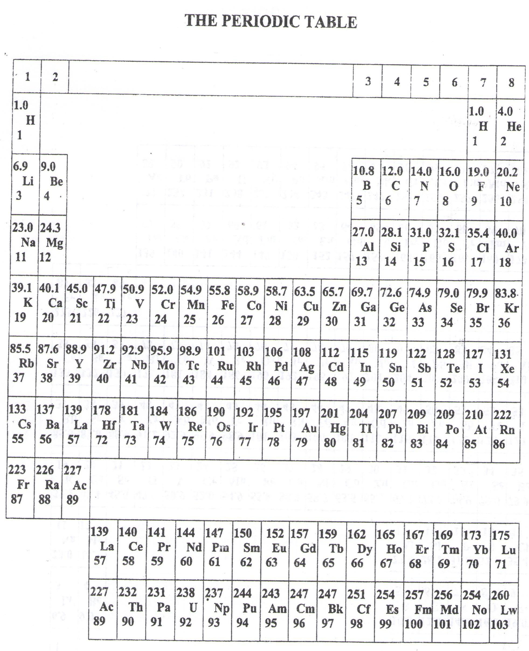 ===END===

WELCOME TO SENIOR SIX, YEAR 2023

This is the last page of the printed paper, Page 22